The Judges Hill Neighborhood Association Code Next Version 3 Position Paper:
Honor the Core of the Downtown Austin Plan’s “Grand Bargain”

The Judges Hill Neighborhood Association (JHNA) urges the City to modify Code Next Version 3 (CNv3) to honor the most critical terms of the Downtown Austin Plan’s (DAP) Grand Bargain, which was reached after extensive, expensive years of outreach to all stakeholders. Citizens from across Austin participated because Downtown is every Austinite's neighborhood. The DAP was passed by Council at the end of 2011, and staff implementation recommendations were drafted in 2014. It undertook a far more exhaustive assay of the area than CodeNEXT can.
The "Grand Bargain" was struck to preserve history, canopy and community in the JHD and the adjacent Northwest District Panhandle (NWD/P) while enabling massive density in the University/Capitol District (U/CD) just two blocks away. This Grand Bargain was not the first time that JHNA negotiated a solution with developers and the City to facilitate a mutually acceptable plan. This position paper is put forward using that same approach
How can CodeNEXT stand on the shoulders of the DAP process in this area? We believe the following 6 items are the minimum that will make our community sustainable. We present them here in concise "bullet" form.
- Retain current Compatibility in the western JHD per that DAP map, but halve its radius and eliminate single family use as a trigger.
- Distribute Density Bonuses per the DAP map.
- Remove the 7 most incompatible proposed uses from the JHD.
- Convert MUPs to CUPs in the JHD, to restore the use accountability present in the DAP.
- Revert the three homes zoned R4A to R2C, to align them with other JHD homes.
- Remove Home Occupations from the JHD--the DAP decided against this in area homes.
Adding these six points would still allow substantial increases in CNv3 entitlements in the JHD and NWD/P. Many of the protections provided by the DAP Grand Bargain will be lost. But these 6 would honor the most critical features of that agreement.
The 2014 draft DAP Staff Implementation Recommendations excluded the JHD from its overlay but for Compatibility Zones and Streetfront Setbacks. We suggest using the DPOZ as the mechanism to implement our 6 points. The current DPOZ only lists what changed in the DAP, but what remained, after thorough argument on both sides, is just as important. An alternate instrument that achieves the same thing would also work.
Otherwise, by leaving out the "no change" DAP decisions on Density Bonuses and Compatibility, CodeNEXT would afford the area considered most at risk less protection than the eastern JHD area and NWD/P, where density was felt to be more important nearer the UC/D.

Here the 6 points are repeated in detailed form:
1. Retain the proposed Compatibility Zones, but outside those zones change proposed Compatibility setbacks and step backs so that:
  - The radius from triggering properties is 270 feet from any Residential-Scale home. That is half of the DAP 540 feet of existing Compatibility Standards, rather than 100 feet, as proposed, which is less than one-fifth of the distance set forth in the DAP. We suggest this reduced distance as a reasonable compromise.

  - That radius is in any direction, regardless of the setback affected or whether an alley or street intervenes (as it is in the DAP).
  - The heights allowed revert to DAP heights until 270’ from triggering properties:
    - No buildings in the initial 30’ setback (height of 0’).
    - Height of 30’ (vs. proposed increase to 35’) between 30' and 50’ away.
    - Height of 40’ (vs. proposed increase to 45’) between the setback and 100’ from the triggering property line
    - Height to rise by an additional 1’ for every 10’ from the triggering property line until a total of 270’ from that line.
    - No commercial zones are to be immune to these rules, to avoid incentivizing repeated rezoning from CNv3 to subvert Compatibility.
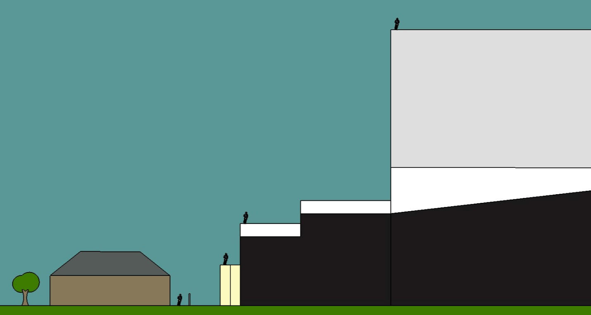
CNv3 Compatibility--100’ radius is too short to sustain history, canopy and homes:
Home on the left and commercial structure to the right, with 100’ radius.
Yellow—setback incursions CNv3 proposed if not the rear of the building.
White --increased CNv3 heights for 60’ structures such as MU2B near homes.
Light gray-- bump in height past the 100’ radius for sample rezone to 120’ height.
Black—current Compatibility heights we propose end at 270’, “half-baked-in” vs. current 540’.

2. Density bonuses in the JHD and the NWD Panhandle (NWD north of W. 15th Street) to be governed by the DAP Density Bonuses Map—see graphic on next page. CNv3 proposed zones still offer JHD commercial properties large increments in FAR and other parameters beyond those in the DAP, including Mixed Use beyond properties on, rather than near, CTCs, which the DAP specifically prohibited.
Western JHD toward Pease Park retains half of the traditional Compatibility Standards and avoids increased density and heights looming over adjacent historic homes, old-growth canopy and the park. This approach is consistent with the 2014 Pease Park Master Plan, in which Council stated that the greenbelt “periphery of the park is as important as the park itself to the quality of visitors’ experience.”
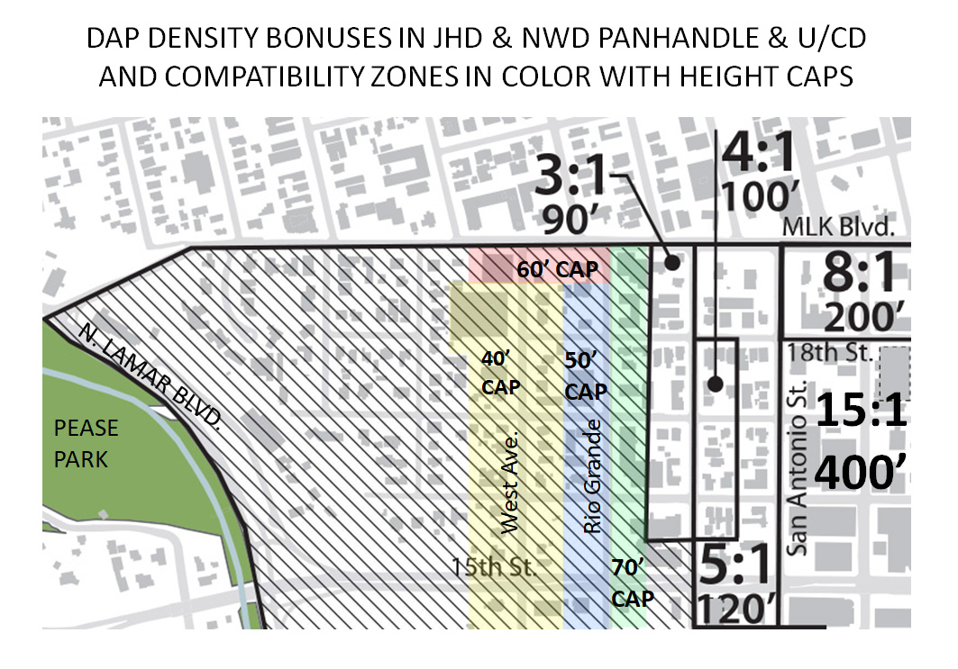

3. The following incompatible uses to be removed from the JHD, but not from the surrounding NWD. The first two uses were pushed north of 13th into our area after they were banned near the jail in the Justice Center Overlay, as part of the DAP:
Bail Bond Services, Pawn Shop, Bar, Restaurant, Hotel/Motel, Hospital, Personal Services
4. All proposed MUP’s to be converted to CUP’s in the JHD. That accountability was present in the DAP and is critical for a historic community roughly 4 blocks square with Downtown on 2 sides and the UNO on another.
5. The three SF-3 properties in the JHD proposed R4A to instead be R2C, consistent with what is proposed elsewhere in the district, rather than splitting homes as in the prior transects before the transects were abandoned.
6. Home Occupations and the businesses they allow to be removed from the JHD, where the importance of maintaining true single family character in a small but dense cluster of historic homes was recognized by the DAP.
Earlier JHNA had acceded to the elimination of Compatibility triggered by JHD homes across MLK in the then-proposed University Neighborhood Overlay (UNO). That allowed massive density increases (heights up to 220 feet) across that street to our north. The DAP/CNv3 Grand Bargain will in turn allow 400-foot-tall high rises just two blocks to east of the JHD. The following 3-D graphic visually highlights the scope of these concessions to density:
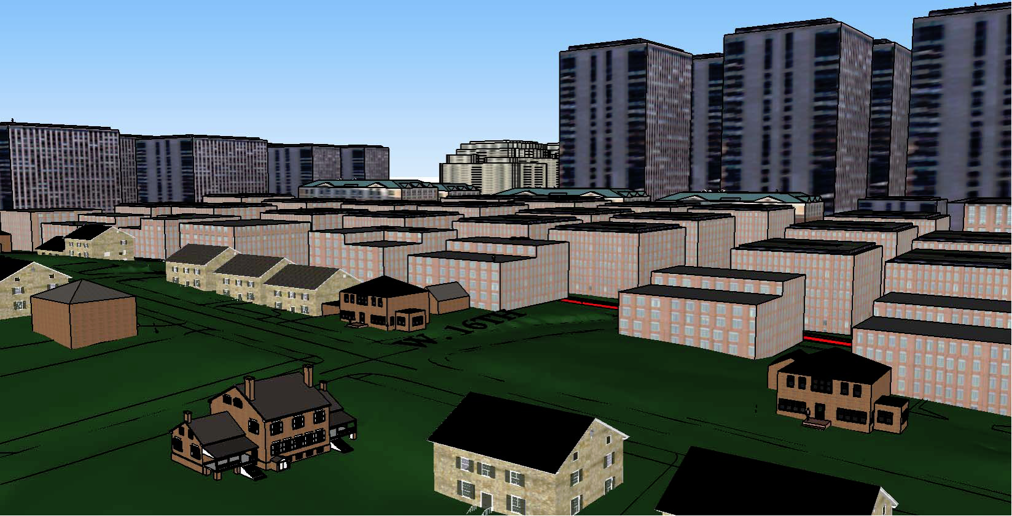
DAP view Northeast across the intersection of West Avenue and W. 16th Street from the JHD across the NWD/Panhandle to the high rises of the UNO (upper left) and the U/CD (upper right). JHD homes are shown in brown brick, JHD homes used as offices, also in the foreground, are in cream limestone, both with pitched roofs. The next tier of salmon-colored boxes are quarter-block mixed use buildings in the NWD/P.

Summary:
Government integrity over time matters to the citizens who take up the call to participate in public processes. We supported a balanced move forward in the DAP, tripling or quadrupling Downtown’s buildable square footage per ROMA Design Group (now McCann Adams). With just 6 tailored points to honor the core of the DAP, we believe we can remain a sustainable community and preserve centuries-old live oaks and a dense collection of critical historic landmarks that make up the unique Austin character of our small corner of downtown. The squares in the quilt that is Austin matter.

Supplemental Supportive Information

Quotes from the DAP about JHD
The DAP was passed by Council at the end of 2011, and staff implementations were drafted in 2014. Austin was already in an extreme boom during these times. Downtown is bigger, denser and more complex than other neighborhoods. The DAP undertook a more exhaustive assay of the area than CodeNEXT can. As part of DAP outreach, the Mayor and Council walked the area with groups of constituents. The DAP provides the fine-toothed plan of what to keep and what to improve downtown. JHNA has relied on the integrity of the DAP’s negotiated solution.
We refer to that solution as the DAP's "Grand Bargain". Everyone recognized the need to encourage more central density while preserving the unique character of the Judges Hill District (JHD) and the Northwest District (NWD). The latter has important historical structures, chronicled by the 1984 Cultural Resources Survey, and mature street trees worth preserving. That is even truer of the JHD, with homes from as early as the 1850s, centuries-old live oaks that cover much of their respective lots, and the Charles Forest overlooking Pease Park.
The DAP delineated one critical distinction between the JHD and the NWD. The NWD had lost many of its residents, so one goal was to draw them back to that area in mixed-use zones. The JHD, though, still thrives as a primarily single family community, with a balanced periphery of reasonably scaled condominiums, apartments and businesses. That distinction led to a pair of adjacent but distinct districts, with goals of preserving the JHD while adding measured mixed-use density in the NWD.
The DAP made preserving the JHD community a specific goal, as illustrated by these quotes from the approved document:
“The DAP is the Downtown’s Neighborhood Plan, and will amend the much more general Comprehensive Plan, providing specificity about the particular geographic area of Downtown.”
“The DAP is the result of a three-year dialogue with the general public and the Downtown community and stakeholders. It involved six Town Hall meetings and scores of smaller meetings and workshops, soliciting input on a wide range of issues and geographic subareas.”

“The character of Downtown ranges from the skyscrapers of Congress Avenue to the single-family neighborhood of Judges Hill. This diversity gives Downtown an authentic sense of place - a unique character that fosters district pride, enjoyment and investment, as well as visitor appeal.”

“Compatibility Zones are proposed, each with specific height standards aimed at providing an appropriate scale transition to the Judges Hill Neighborhood.”

“Mixed Use: An appropriate mix of residential and non-residential uses should be allowed in all parts of Downtown, except for Judges Hill, which should generally be preserved as a single-family residential neighborhood.”

“Downtown’s fabric of historic residential and commercial structures creates a unique identity.”

“Downtown’s historic fabric is at risk of being demolished. More than 150 potentially significant historic properties, identified in Austin’s 1984 Cultural Resources Survey, have been demolished in Downtown over the past 35 years.”

“The DAP recognizes the importance of the historic fabric of the original city and has identified nine individual “districts” that are generally cohesive in character, in terms of building form and scale, which is often a result of their historical development.”

“Historic preservation is important if Downtown is to continue to develop in a way
that is authentically and uniquely Austin.”

We ask that you respect the years of work that the recent Council, Staff, Consultants and Citizen Stakeholders spent creating a detailed, balanced, unique Downtown Austin solution in the DAP. The bare-bones proposal outlined in this document is a rational compromise that moves forward while respecting the most critical features of that document.

